Business Opportunity day!
H
appy much?? This is the question you need to ask yourself after taking a look at this group of amazing hopefuls!
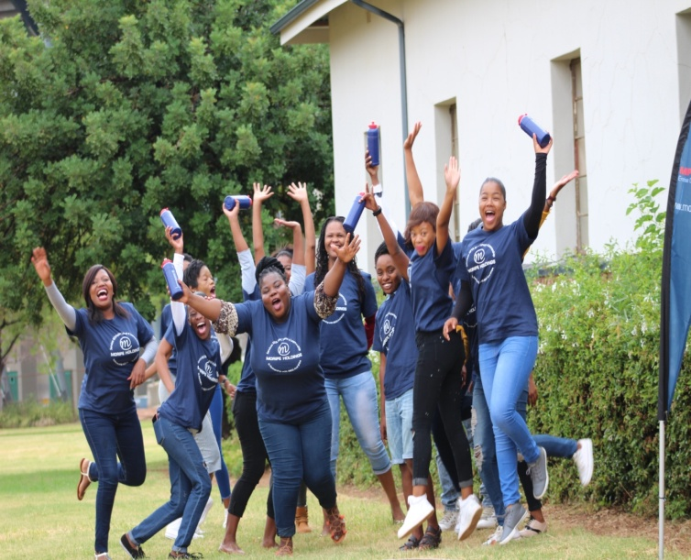
25th January 2018 was the date set for Business Opportunity Day. This event took place in the North West province, Phokeng section.
M
oripe Holdings along with Royal Bafokeng Enterprise Development was rightfully allocated with 150 learners to be trained on new Venture Creation Learnership for a period of 12 months. The classes were set to commence in October 2017 and Yes! They are moving to greater heights! Done and Dusted with theoretical work and moving towards practical’s as of February 2018 as part and parcel of their practical’s. This day came as push and a drive in encouraging and empowering the learners, by giving them a platform to engage and interact with different big players within the corporate industry.
T
his was a day aimed to inspire & encourage learners to pursue entrepreneurship as an option which falls within their scope, providing them with market linkage and facilitating possible deals between learners and the various entrepreneurs that were part of this day, to sharpen their ability to identify what the market wants and finding innovative ways to be proactive and instil principles.
The team, speakers, friends, families & came through in support of this great initiative, for this day to be such a successful and fruitful event. By the look of things, Moripe Holdings can proudly say, the objective for this particular day has been achieved.

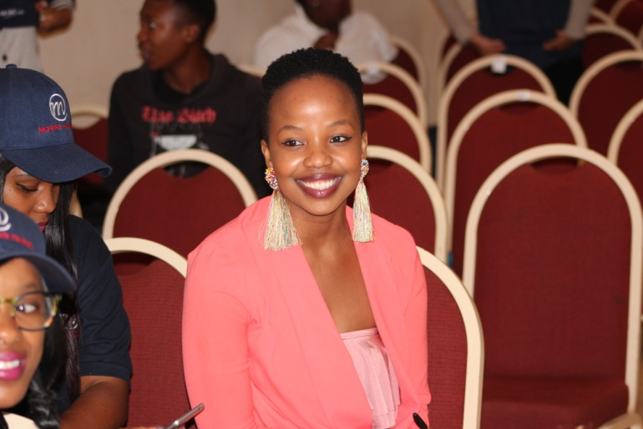
“Most of you will go out that door inspired, motivated and gained knowledge, because you’ll determine largely whether you want to fail or succeed because civilisation hangs in the balance of who you want to be, for the world of tomorrow” These Are the wise words of inspiration uttered by the beautiful Khumo from North West.

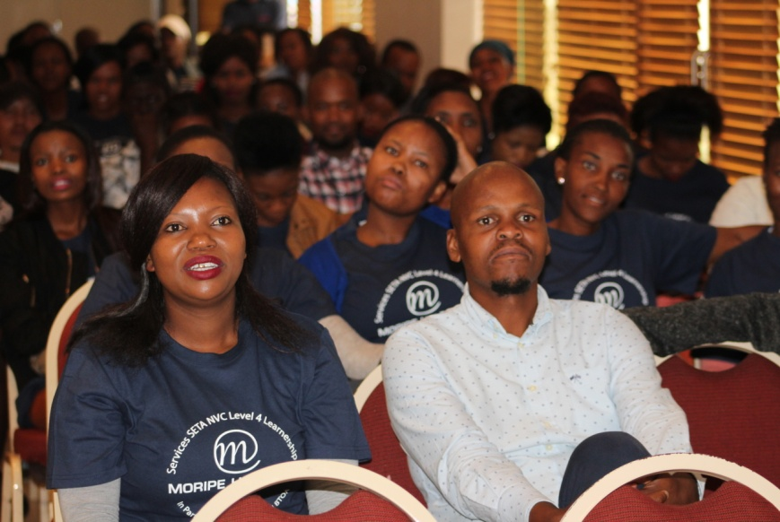

This is a picture of a few hopefuls listening attentively to one of our speakers at the Business Opportunity Day.

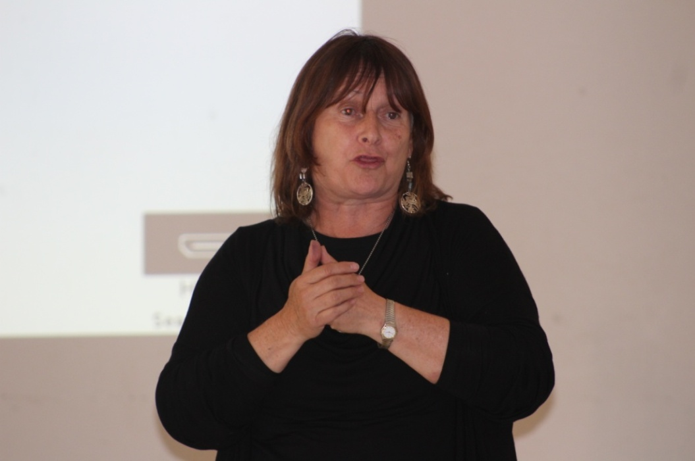

This is a depiction of how one of our guest speaker, the amazing Janet from skills village presenting on event co-ordination.

